**Task1:**

import java.util.Scanner;

public class Task1 {

public static void main(String[] args) {

try {

Scanner scanner = new Scanner(System.in);

System.out.print("Enter a string of capital letters: ");

String inputString = scanner.nextLine();

if (!inputString.matches("[A-Z]+")) {

throw new Exception("Some error occurred");

}

if (inputString.contains("A") || inputString.contains("B")) {

throw new Exception("A");

}

System.out.println("Input is valid: " + inputString);

} catch (Exception e) {

if (e.getMessage().equals("A")) {

System.out.println("Character 'A' found.");

} else {

System.out.println("Some error occurred");

}

}

}}

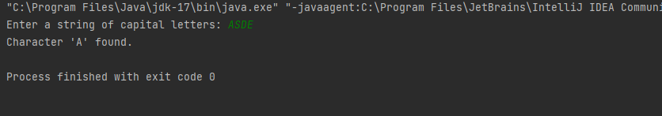

**Task2**:

import java.util.Scanner;

public class Task2 {

public static void main(String[] args) {

try {

Scanner sc = new Scanner(System.in);

System.out.print("Enter a string of capital letters: ");

String inputString = sc.nextLine();

if (!inputString.matches("[A-Za-z]+")) {

throw new InvalidCharacterException("Some error occurred");

}

if (inputString.contains("A") || inputString.contains("B")) {

throw new Exception("A");

}

System.out.println("Input is valid: " + inputString);

} catch (InvalidCharacterException e) {

System.out.println("Invalid character found: " + e.getMessage());

} catch (Exception e) {

if (e.getMessage().equals("A")) {

System.out.println("Character 'A' found.");

} else {

System.out.println("Some error occurred");

}

}

}

}

class InvalidCharacterException extends Exception {

public InvalidCharacterException(String message) {

super(message);

}

}

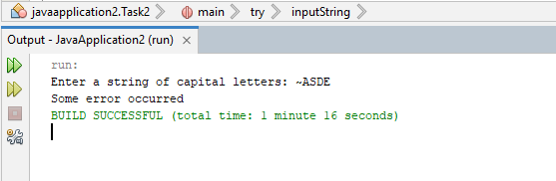

**Task3**:

import java.io.*;

public class Task3 {

public static void main(String[] args) {

String Input = "This is Task#3 of SCD lab#5.";

int stringLength = Input.length();

System.out.println("Length of the string: " + stringLength);

String fileName = "k213821.txt";

try (Writer writer = new FileWriter(fileName)) {

writer.write(Input);

System.out.println("String has been written to the file: " + fileName);

} catch (IOException e) {

System.err.println("Error occurred while writing to the file: " + e.getMessage());

}

try (Reader reader = new FileReader(fileName)) {

StringBuilder storedString = new StringBuilder();

int character;

while ((character = reader.read()) != -1) {

storedString.append((char) character);

}

System.out.println("String fetched from the file: " + storedString.toString());

} catch (IOException e) {

System.err.println("Error occurred while reading from the file: " + e.getMessage());

}

}

}

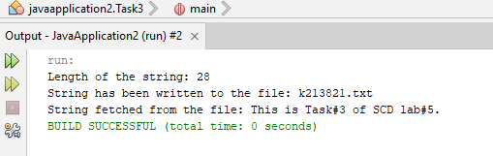

**Task4:**

public class Task4 {

public static <T extends Number> double add(T N1, T N2) {

return N1.doubleValue() + N2.doubleValue();

}

public static <T extends Number> double subtract(T N1, T N2) {

return N1.doubleValue() - N2.doubleValue();

}

public static <T extends Number> double multiply(T N1, T N2) {

return N1.doubleValue() * N2.doubleValue();

}

public static <T extends Number> double divide(T N1, T N2) {

if (N2.doubleValue() == 0.0) {

throw new ArithmeticException("Division by zero gives math error.");

}

return N1.doubleValue() / N2.doubleValue();

}

public static void main(String[] args) {

int intN1 = 3;

int intN2 = 6;

double doubleN1 = 21.3;

double doubleN2 = 47.9;

System.out.println("Integer Addition : " + add(intN1, intN2));

System.out.println("DOuble Addition : " + add(doubleN1, doubleN2));

System.out.println("Integer Subtraction : " + subtract(intN1, intN2));

System.out.println("DOuble Subtraction: " + subtract(doubleN1, doubleN2));

System.out.println("Integer Multiplication: " + multiply(intN1, intN2));

System.out.println("DOuble Multiplication : " + multiply(doubleN1, doubleN2));

System.out.println("Integer Division : " + divide(intN1, intN2));

System.out.println("DOuble Division : " + divide(doubleN1, doubleN2));

}

}

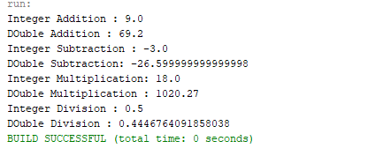

**Task5:**

import java.util.HashSet;

import java.util.Iterator;

import java.util.ArrayList;

public class Task5{

public static void main(String[] args) {

HashSet<Object> customHashSet = new HashSet<>();

customHashSet.add("Haroon");

customHashSet.add("Mirza");

customHashSet.add(3);

customHashSet.add(8);

customHashSet.add(2);

customHashSet.add(1);

System.out.println("Iterating through the custom HashSet:");

Iterator<Object> hashSetIterator = customHashSet.iterator();

while (hashSetIterator.hasNext()) {

Object element = hashSetIterator.next();

System.out.println(element);

}

ArrayList<Object> customArrayList = new ArrayList<>();

customArrayList.add("SCD");

customArrayList.add("LAB");

customArrayList.add(2);

customArrayList.add(5);

customArrayList.add(9);

customArrayList.add(3);

System.out.println("Iterating through the ArrayList:");

Iterator<Object> arrayListIterator = customArrayList.iterator();

while (arrayListIterator.hasNext()) {

Object element = arrayListIterator.next();

System.out.println(element);

}

}

}

